This is the implementation of first requirement: if the customer rents items of different categories, or the customer rent an item of type new release then they will get double points.

The Order class assigns the appropriate strategy to calculate the point. This is only implemented in the Order class and not other OrderComposite or OrderDecorator so that you can see clearly. The reason for this is: the strategies are set based on the input, not manually, so it is changed whenever a customer adds a new item to the order.

The strategies are in package “strategies” under names: DefaultPointStrategy and DoublePointStrategy.

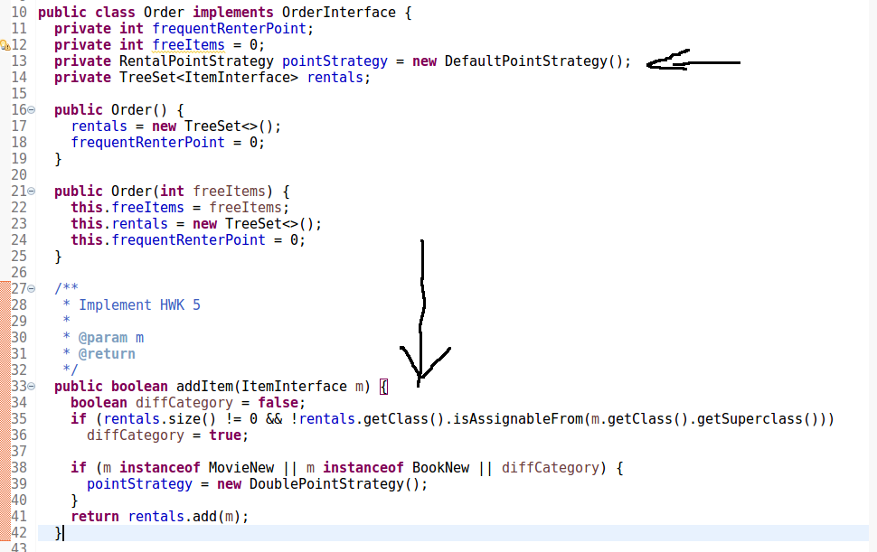

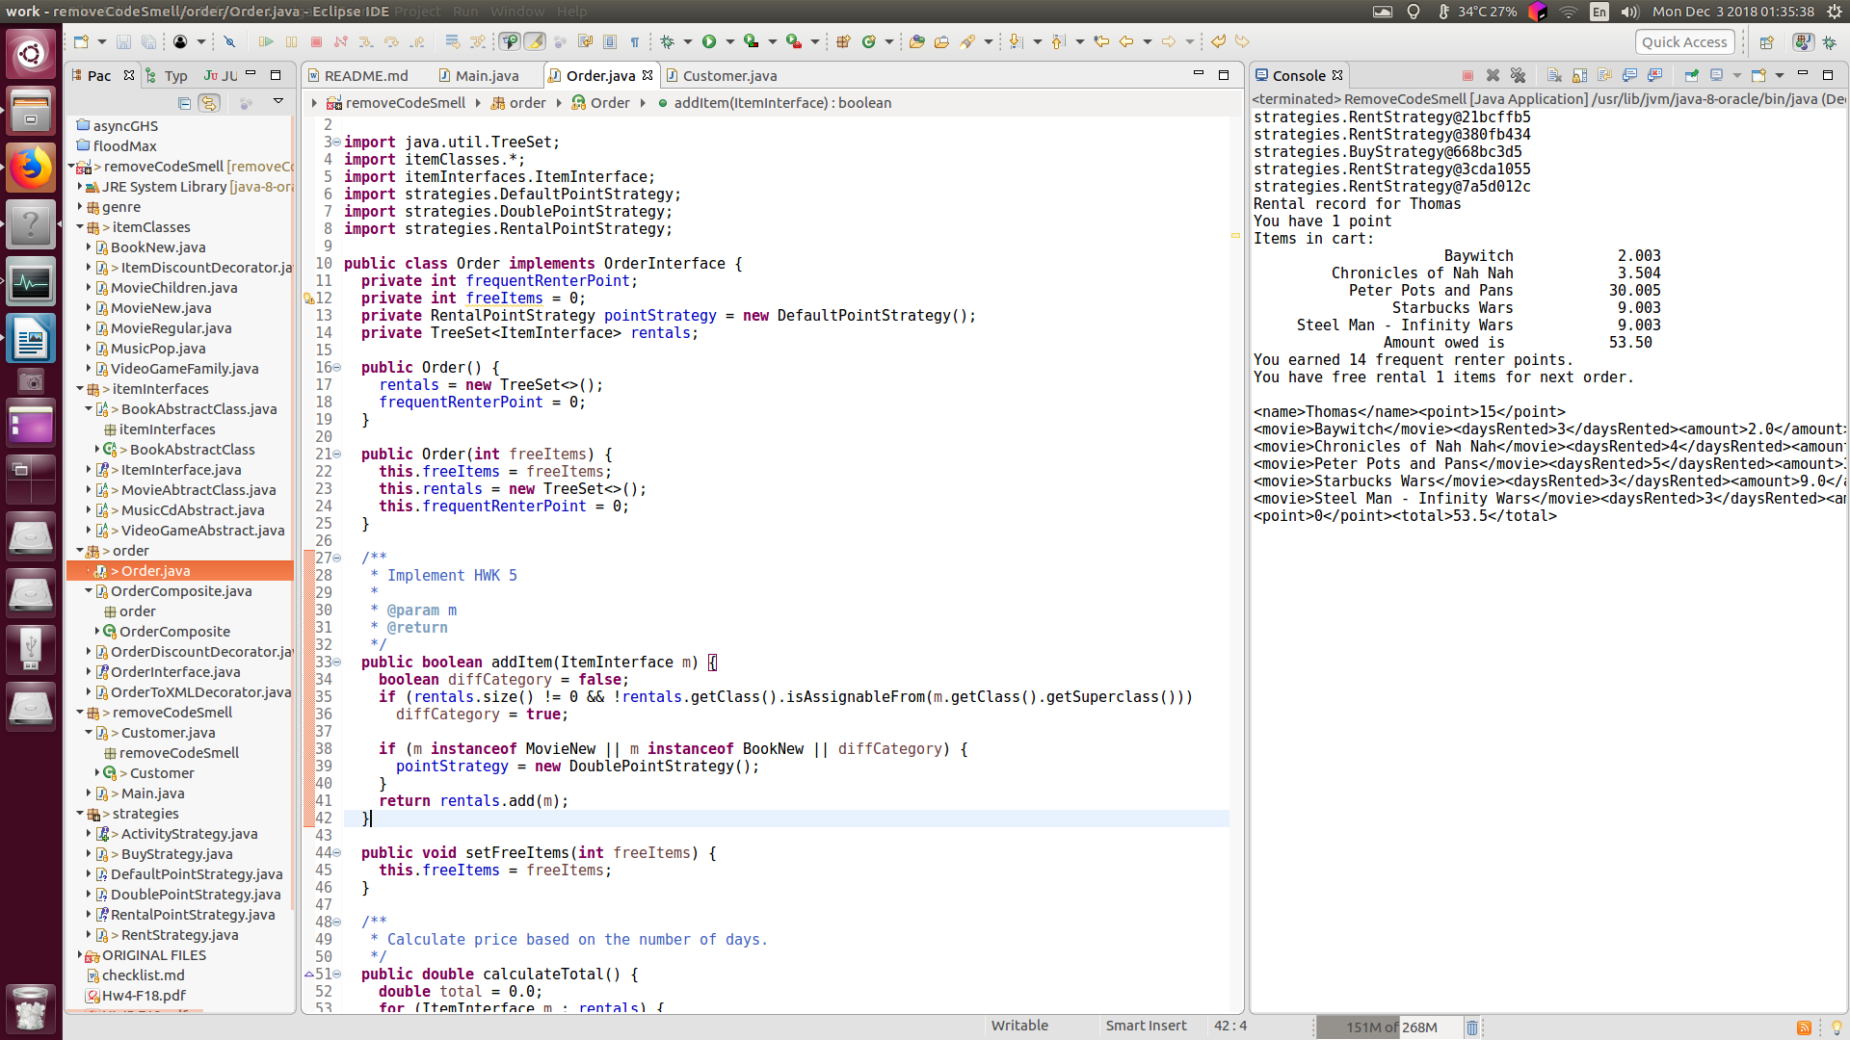

This is implementation of the second requirement: if the frequent rental point is larger than 10, then the customer get a free item rental for next time.

